WOLVERHAMPTON PRIMARY VOLLEY2s (AMBER) COMPETITION
Following the successful Volley2s Festival in October we are now staging a Volley2s Amber Competition.
WHO IS THE VOLLEY2S AMBER COMPETITION FOR?
The Volley2s Amber Competition is for children in Years 4 and 5.
WHAT IS VOLLEY2s?
Volley2s is an adapted 2v2 version of Volleyball which has been developed by Volleyball England to introduce the game of volleyball to children of all abilities and disabilities aged 7-11 (KS2)
Volley2s has four developmental stages RED, AMBER, GREEN, GOLD.
This competition will be based on Volley2s Amber.
WHAT IS THE FORMAT?
The event will be a combination of 2v2 games and development challenges
The rules of Volley2s Amber will be explained to the children who will then play a few practice games to familiarise themselves with the game.
Then there will be a combination of games and challenges (around the volley and serve, the two main skills needed in Volley2s Amber)
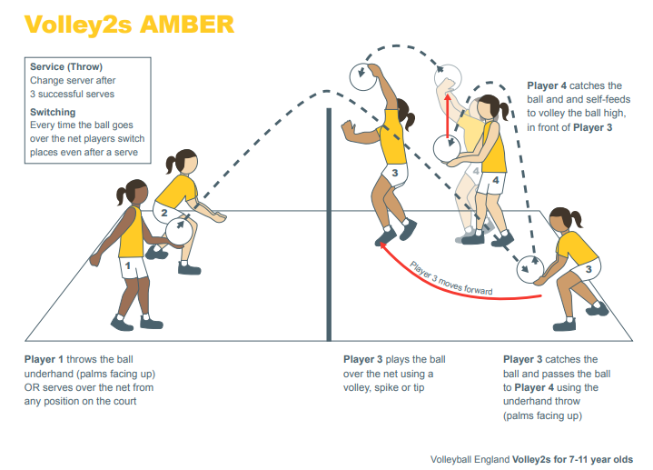
Scores for games and challenges will be added together for all teams to record how they have progressed.

WHERE CAN I GET FURTHER DETAILS OF VOLLEY2s?
Download for FREE the Volley2s Guide for Teaching and Coaching from Volleyball England at Volleyball England
FESTIVAL DETAILS
Date:- Tuesday, March 15th 2022
Venue:- St Peter’s Collegiate Academy
Times:- 2:00pm to 4:00pm
Teams:- 2 a-side (Boys, Girls or Mixed) A maximum of 4 teams per school
Entries to:- Nicky Spittle (sgo@olscmail.org.uk)
Entries open: 17th February 2022
Entries close: Friday 11th March 2022

