**WHEN?**

**30th November**

***At ONEWA School***

*9.00am-3.30pm*

*Delivered by regional Tutor through* ***YST.***

**HOW?**

1. **Access a Start 2 Move Course**
2. To enable your school to develop teachers to support this vision we are offering a national Start 2 Move course for your EY/KS1 deliverers. This course is tutored by national Tutors and will be supported by resources.

**WHO? *For any member of staff in EY/KS1 phase***

**Outcomes:**

Through the course, your staff will be able to develop Pupils fundamental movement skills, support them to become increasingly competent and confident and access a broad range of opportunities to extend their agility, balance and coordination, individually and with others.

This is a practical course……Please bring appropriate clothing and packed lunch…..

 

**Free to Connect Ed schools through the YST partnership**

Packed lunch required/practical clothes

**WHY?**

A Vision for Primary Physical Education

Physical Education in primary schools provides children with a movement foundation for lifelong participation in physical activity, enabling them to be **physically literate;** this supports the development of competent movers.

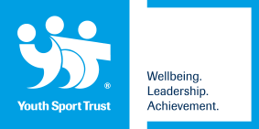



To secure place please complete the following and email to **sam.fullwood@connectedpartnership.com**

Name:

School: